AKH-0.66 / TDΦ60 current transformer
- Product characteristics
Product round hole design, beautiful appearance, convenient installation, wiring, mainly used for power operation and maintenance, data center and other projects, the general output of 20mA small current signal, has the advantages of small volume, high accuracy, strong load capacity, convenient installation and other advantages.
- Model description
AKH- 0 66 - TD □ □

Rated current ratio
Specification: 60
Current transformer code name Rated voltage (kV)
Product series code name

- Specifications and dimensions
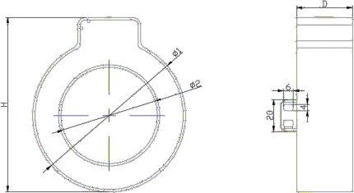

size  specifications | Overall dimensions (mm) |  |  | The perforated size  (mm ) | Tolerance (mm)
 | Φ 1 | H | D | Φ 2
TD - Φ60 | 95 | 108.5 | 35 | 60 | ±2

- Specification and parameter comparison table

model | Rated current ratio | Class of accuracy | Rated current load | Through the heart number of  turns | The perforated size (mm )
TD-Φ60 | 300/5A | 0.2 | 2.5VA | 1 | Φ 60

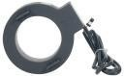
- Use the environment
- Rated operating voltage AC 0.66kV (equivalent AC 0.69kV, GB 156-2017)
- Rated frequency is 50-60Hz
- Ambient temperature-30℃~90℃
- (4) The altitude is 3,000 m
- Power frequency withstand voltage of 3000V / 1min 50Hz
- Used for no direct invasion of rain and snow areas, no serious pollution and violent vibration places

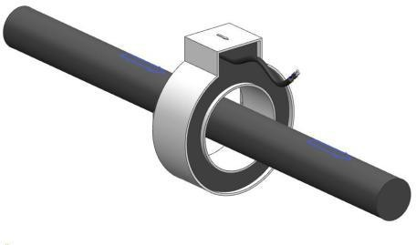
- Installation

